**CHAROTAR UNIVERSITY OF SCIENCE AND TECHNOLOGY**

**CHAROTAR INSTITUTE ON PARAMEDICAL SCIENCES**

**National Level Conference on**

**Basics to Advance in Medical Imaging Technology**

On 9th of November 2019, Department of Medical Imaging Technology organised a National level conference on the theme,” Basics to Advance in Medical Imaging Technology”. The conference was organised in collaboration with GE Healthcare, one of the leading company in health care industry.

The major objectives of the conference were –

* To congregate delegates from different universities and hospitals across India.
* To bring experience and renowned speakers under one roof.
* To impart students and delegates with knowledge on recent advancement in Medical Imaging Technology.
* To aware students about career and newly emerging job prospects in the field of Medical Imaging Technology.
* To establish a base for organizing academic programmes in future.
* To unleash management skills of students and faculties.

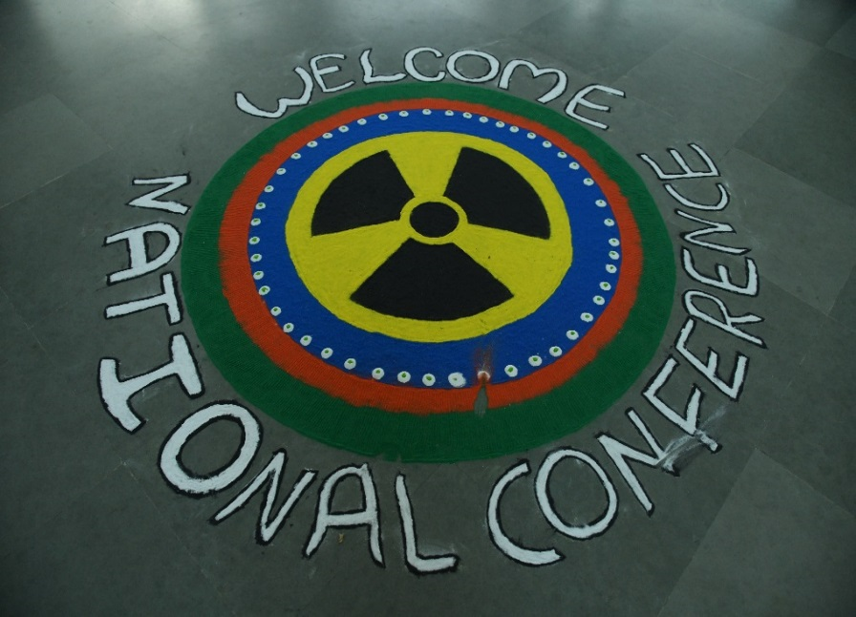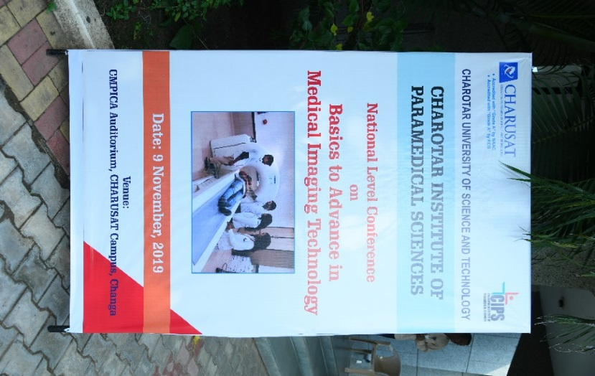

Programme started with registration followed by breakfast from 8:30 early morning. The registration process was completed around 9:15 am. Students , faculties and technologist of Various Universities ( R.K. university , Rajkot , Parul University , Vadodara , Symbiosis International University , Pune , Surat Medical Collage , Surat , Pramukhswami Medical College, Karamsad , Charotar Institute of Paramedical Sciences) from Gujarat and other neighbouring state participated in conference.

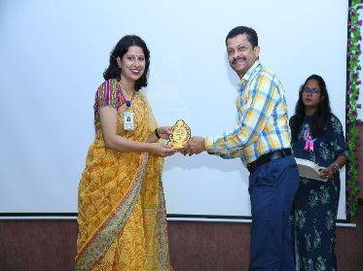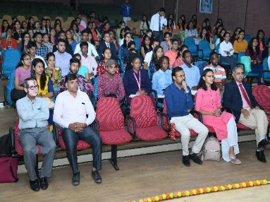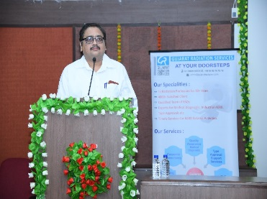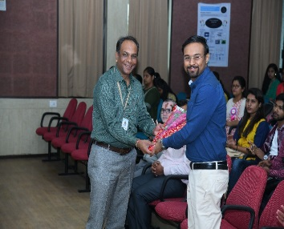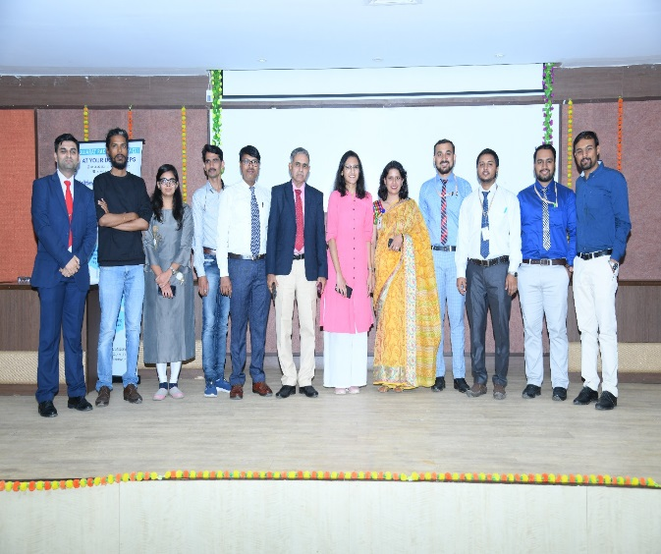

Officially programme started with welcome speech of Mrs. Dolly Sharma (HOD-MIT). Immediately after welcome speech Dr. Deepak V. Mehta (Prof. & guide Pramukhswami Medical College) delivered has talk on the topic “Recent Advancement in Medical Imaging Technology” which was followed by Dr. Sunny Mishra (Radiologist, CHARUST Hospital) on the topic “CT Coronary Angiography”. Mr. Kalpesh Parrikar (Application Specialist GE, Mumbai) delivered his talk on topic “Radiation Safety, Contrast Medium and Adverse Drug Reactions”. Ms. Yatha Mehta (Radiation Safety officer for medical diagnosis and Nucleonic Gauges Quality Manager for NABH and NABL) delivered her talk on “AERB guideline and Quality Assurance in Medical Imaging Technology”. After completion of her talk lunch was organized at 12:30 Pm followed by Poster Presentation. Students from R.K. University and CIPS participated in poster presentation competition.

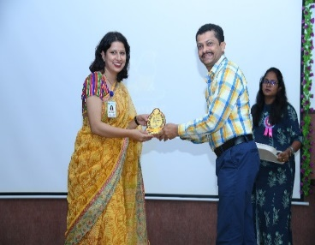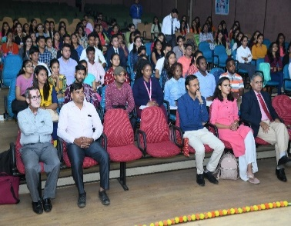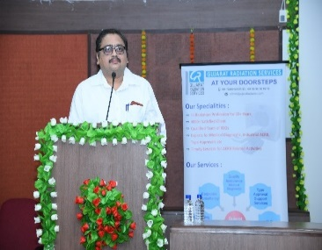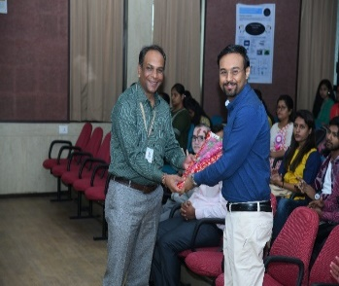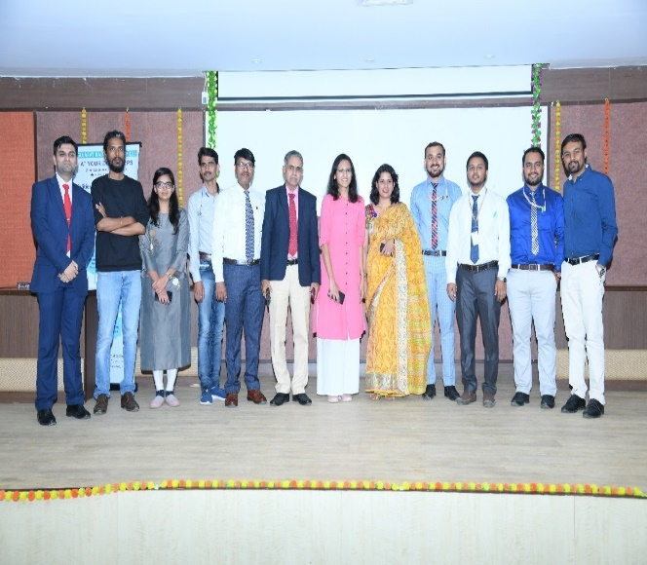

Post lunch programme started at 1:20 Pm. Mr. Manish Hathimare (RSO manager , Krishna Shalby Hospital , Ahmedabad) was the first speaker post lunch where he delivered his talk on topic “Radiation safety and hazards to Radiation Professionals working in Hospitals “. After his informative talk Mr. Purwak Pandya continued the session with his lecture on the topic “MRI Safety”. Mr. Ravikant Kamal (Senior Scientist Jajal Medical Sciences, Vadodara) delivered a detail and very informative talk on “Recent Advancement in Orthopaedic Imaging” where he highlighted role of imaging technologist and emerging scope of 3D post processing. This was the last talk of the event. Prize were distributed to winners of poster presentation. Feedback from students of different university was taken. Students responded positively and were motivated to participate in such programmes in future. The program was concluded with gratitude by Mr. Anupam Niraula. All participants were served high tea and snacks at 4:15 PM and programme was officially concluded.